# Automated Mobile Testing

|  |
| --- |
|  |

## Overview of popular testing products and how they function

OPEN SOURCE

APPIUM (Android and iOS)

*Built Selenium 3.0 WebDriver API and SDK*

-Appium testing is performed through a web server.

-The Appium product consists of a WebDriver, TCP server/client on phone, and the device running its default testing software (UiAutomation on iOS or UIAutomator on or Android ) with either javascript for iOS and .jar/Java for Android.

- The WebDriver runs the Appium script language that communicates with the device. The device has a server running that receives the input and directs it to the app testing software. The command is then processed on the app. The result of that test is then sent back through the channels to the Appium server to be logged and analysed.

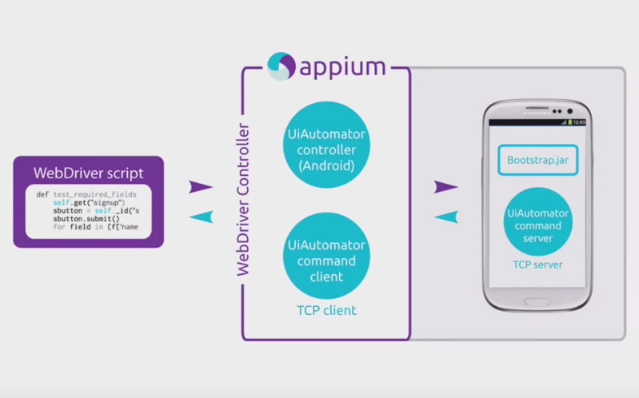

Calabash (Android and iOS)

Can test on over 1,000 real mobile devices in the cloud.

Xamarin Test Cloud: one word->expensive. $1000/month for two apps.

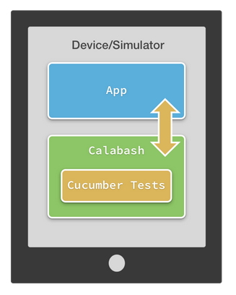

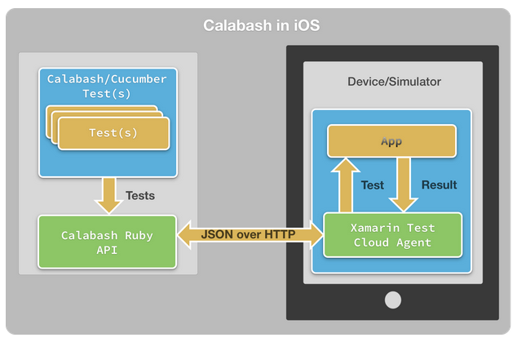

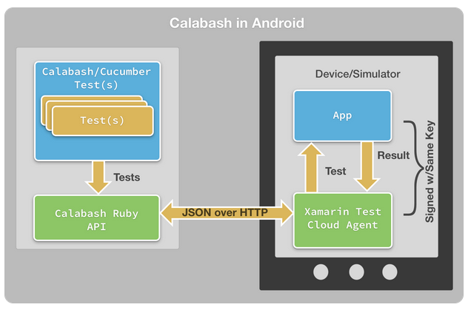

MonkeyTalk (Android and iOS)(by Gorilla Logic)

*Currently not available for download as it is in public Beta stage.*

Cross-platform playback and recording.

Own language called MonkeyTalk. A cleaner version of Javascript; tries to make it more English-like.

Can run test numerous times with various inputs and can validate multiple results from a simple CSV file.

Supports device testing in the cloud.

Enterprise Software

Perfecto mobile

## “Our Test Automation solution empowers dev teams by allowing them to execute cross-platform tests on real devices connected to live carrier networks.” – Perfecto mobile

ScriptOnceTM Automation – write it once, run it on multiple devices.

Access to real devices; not emulated.

UserTesting

Different approach. Not automated; community driven.

You are given access to a testing community which consists of everyday people. They download and test your app and then a video is uploaded for you to watch later.

DeviceAnywhere Enterprise Automation

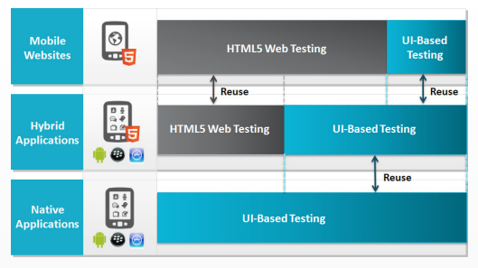

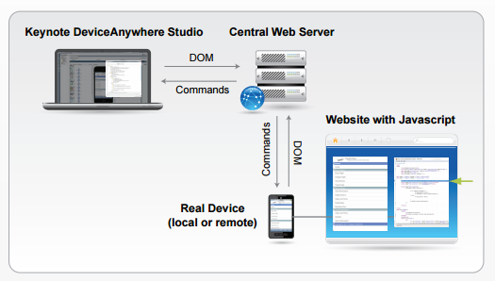

Background *[pure copy and paste from Google]*

In a “State of Mobile” study of 1,040 software developers, testers, and consumers conducted by SmartBear and published in early 2014, we discovered, among other things, that:

* Nearly 30% of those building any kind of apps were building mobile apps
* 54% of respondents who were building mobile apps had entered the space within the past two years.
* 84% of those who were not currently building mobile apps planned to enter the space in the near future.
* 30% of companies were planning to develop 5-20+ new apps in 2014.
* 40% of consumers download 5-20+ apps in a single month.

55% majority of mobile app developers in our survey were working on applications for Business Productivity, Utility, and Finance.

**Different types of apps:**

* Native ( Android, iOS, Windows)
* Hybrid (Appcelerator, Ionic; web apps packaged in a native-app wrapper)
* Web (HTML5 and JS and CSS)

**Types of Mobile App Testing:**

To address all the above technical aspects, the following types of testing are performed on Mobile applications.

* **Usability testing** – To make sure that the mobile app is easy to use and provides a satisfactory user experience to the customers
* **Compatibility testing** – Testing of the application in different mobiles devices, browsers, screen sizes and OS versions according to the requirements.
* **Interface testing** – Testing of menu options, buttons, bookmarks, history, settings, and navigation flow of the application.
* **Services testing** – Testing the services of the application online and offline.
* **Low level resource testing** – Testing of memory usage, auto deletion of temporary files, local database growing issues known as low level resource testing.
* **Performance testing** – Testing the performance of the application by changing the connection from 2G, 3G to WIFI, sharing the documents, battery consumption, etc.
* **Operational testing** – Testing of backups and recovery plan if battery goes down, or data loss while upgrading the application from store.
* **Installation tests –** Validation of the application by installing /uninstalling it on the devices.
* **Security Testing** – Testing an application to validate if the information system protects data or not.

**Approaches to mobile testing:**

**Object based mobile testing tools** – automation by mapping elements on the device screen into objects. This approach is independent of screen size and mainly used for Android devices.

* Eg:- ranorex, jamo solution

**Image based mobile testing tools** – create automation scripts based on screen coordinates of elements.

* Eg:- Sikuli, Egg Plant, RoutineBot